Form home page The user view the Website of the Angelite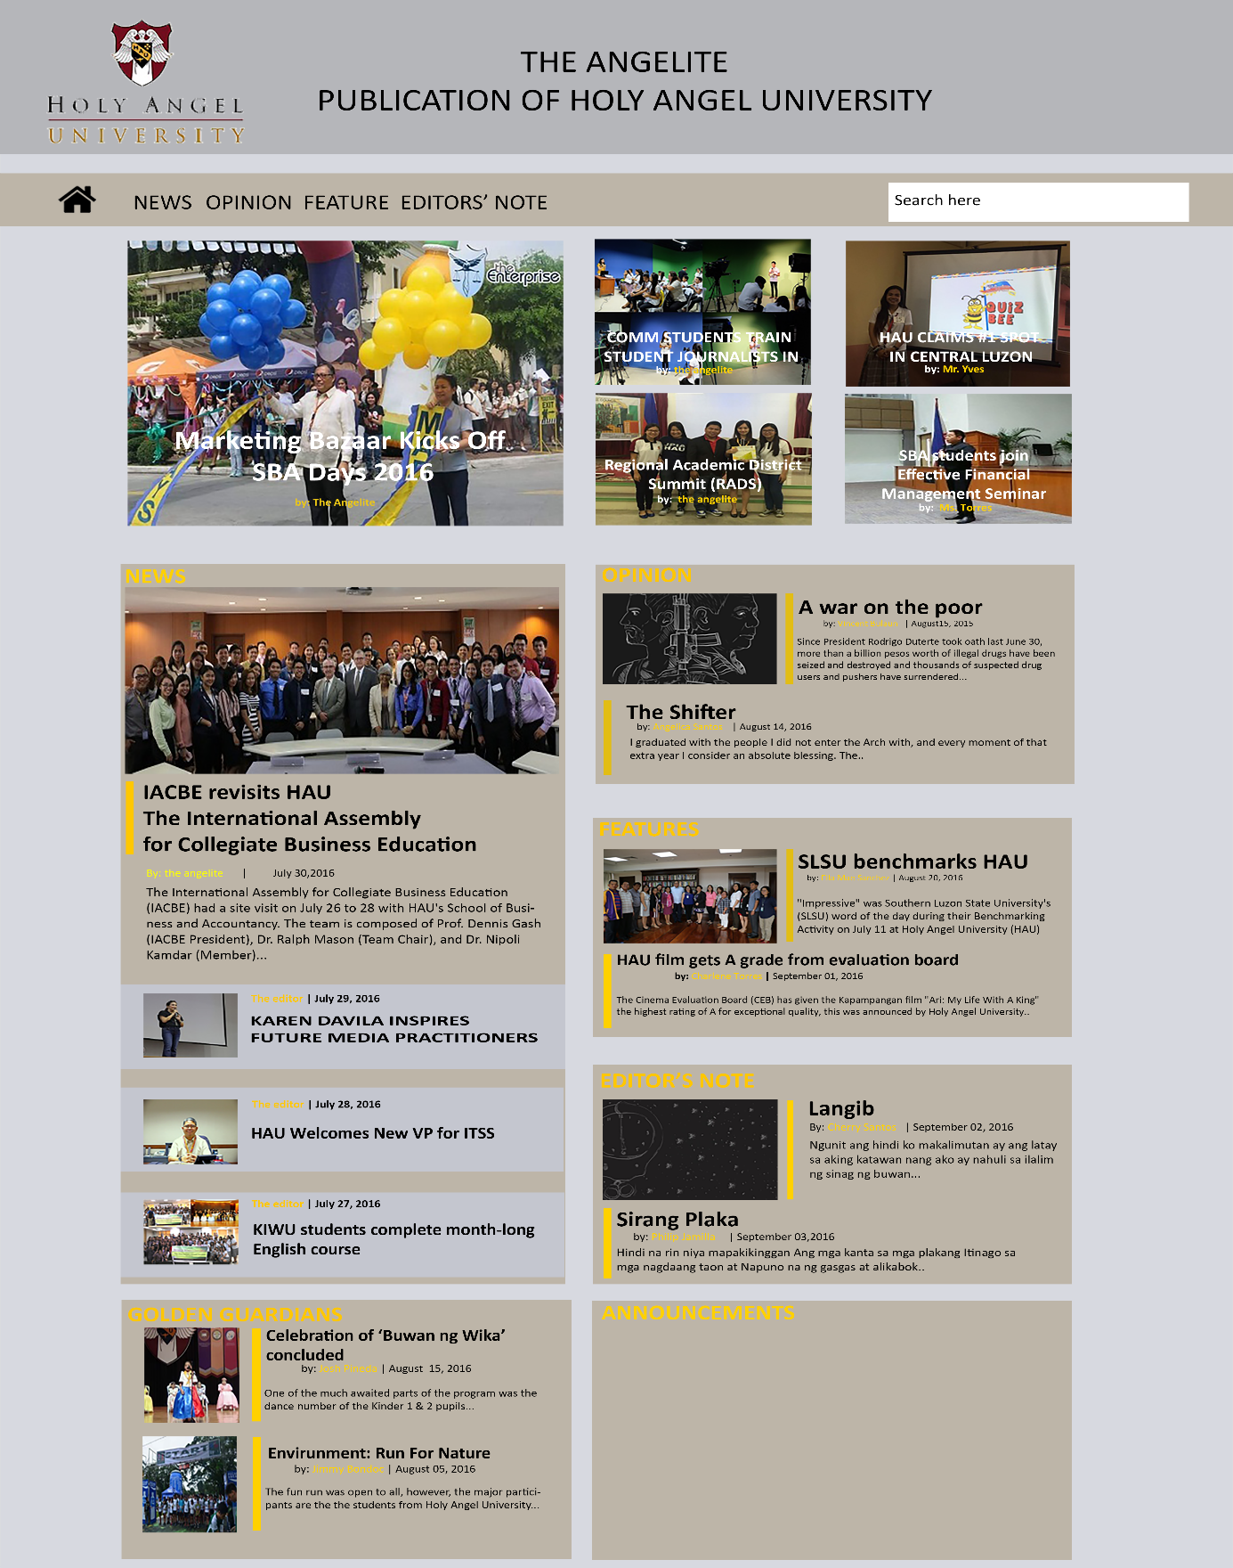 [www.theangelite.com](http://www.theangelite.com)

Once the user visit the site he want to view the Opinion section

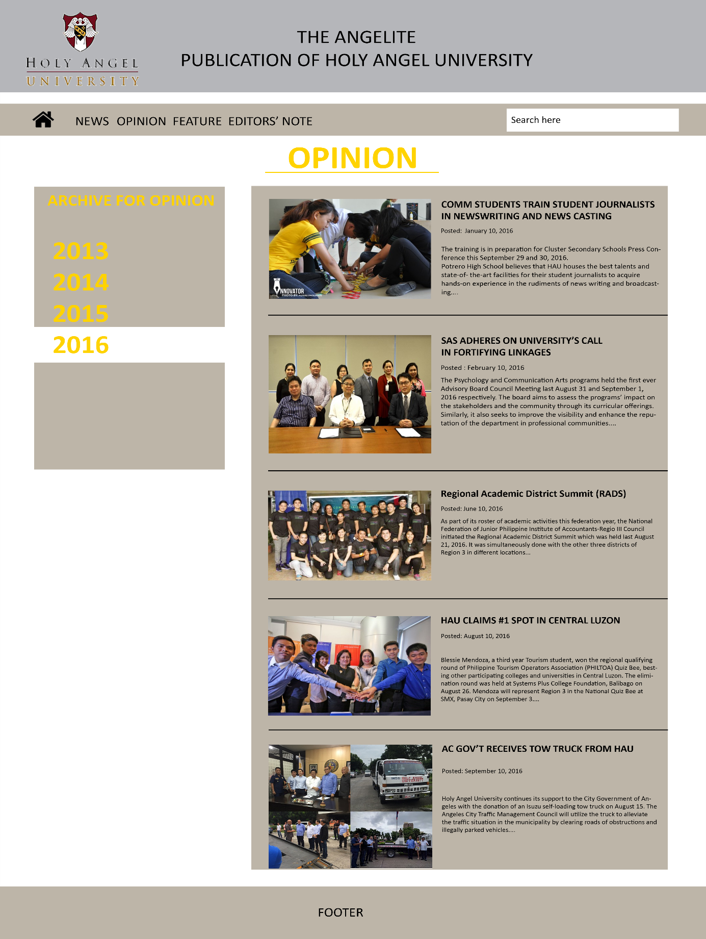

Once they visit the Opinion section the user will read the article about the SBA College Days

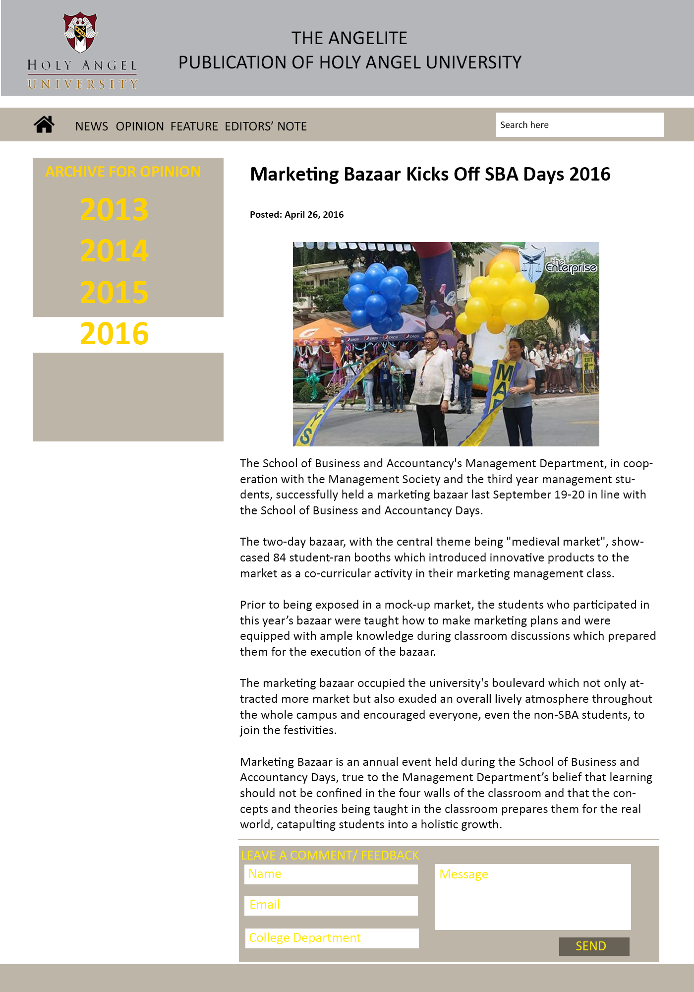

When the user leave a comment it will posted in the The Angelite Voice Section

